Let me steal this moment from you now
Two-person exhibit with Lee Materazzi & Balint Zsako
February 1st - March 13th, 2021

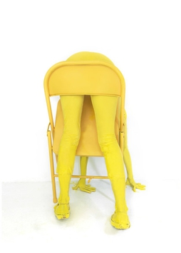 | Lee Materazzi  Bent Over Chair, 2019  Verso  c-print  25” H x 18” W  Edition of 10 plus 2 AP  (MATL-031) | $ 2,000
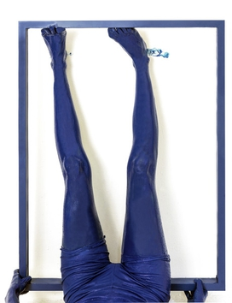 | Lee Materazzi  Straightening A Frame, 2019  Verso  c-print  25” H x 18” W  Edition of 10 plus 2 AP  (MATL-022) | $ 2,000
 | Lee Materazzi  Babyskin  signed on the back  c-print  24 x 18  (MATL-053) | $ 2,000
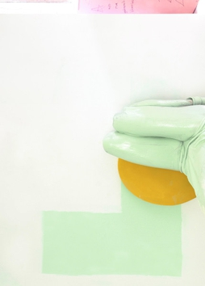 | Lee Materazzi  Teal, 2021  signed and dated on verso  c-print  25 x 18  (MATL-052) | $ 2,000
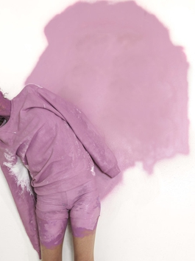 | Lee Materazzi  Pink Sideways, 2021  signed and dated on verso  c-print  25 x 18  (MATL-051) | $ 2,000
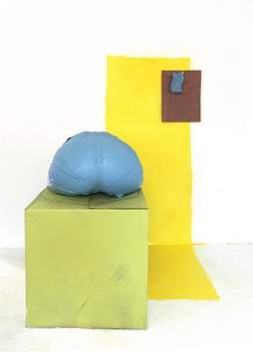 | Lee Materazzi  Sponge, 2021  signed and dated on verso  c-print  25 x 18  (MATL-049) | $ 2,000
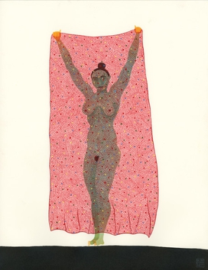 | Balint Zsako  Here We Are 17, 2020  signed and dated in the lower right hand corner  Watercolor and ink on paper  13 x 10  (BZ007) | $ 1,450
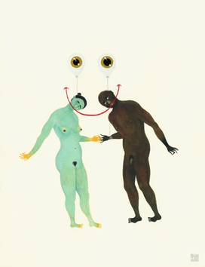 | Balint Zsako  Here We Are 121, 2020  signed and dated in the lower right hand corner  Watercolor and ink on paper  13 x 10  (BZ015) | $ 1,450
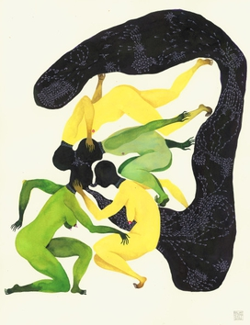 | Balint Zsako  Here We Are 139, 2021  signed and dated in the lower right hand corner  Watercolor and ink on paper  13 x 10  (BZ028) | $ 1,450
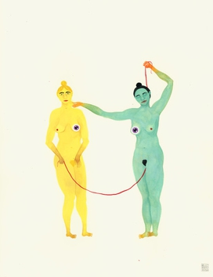 | Balint Zsako  Here We Are 135, 2020  signed and dated in the lower right hand corner  Watercolor and ink on paper  13 x 10  (BZ026) | $ 1,450

