Works available by Kira Dominguez Hultgren
22 September 2022

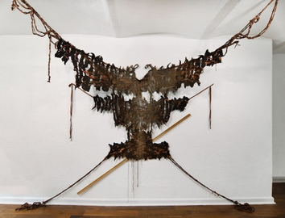 | Kira Dominguez Hultgren  The Eagle Doesn't Fall Far from the Tree, 2022  CA wool, grandma's silk, artist's hair, LA jute, PVC, wood  96 x 105 x 36 (variable)  (DOMK-044) | $ 9,500
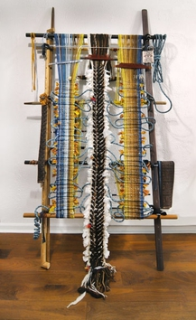 | Kira Dominguez Hultgren  In the Silence between Mother Tongues, 2022  Silk from a salwar and chuni that artist's grandmother wore, two nalas, rope from artist's favorite Utah climbing gym, paracord, found wood, plastic and metal loom bars, heddle rods and shed rods, eye bolts, hand-spun wool, skin dyed and acid dyed wool, digital handwoven fabric mostly in cotton, mohair and metallics, various other yarns and fabrics in cotton, wool, acrylic, linen, and mohair  92 x 55 x 12  (DOMK-045) | $ 9,500
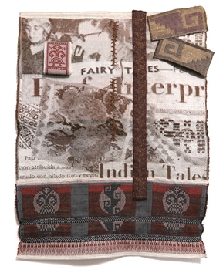 | Kira Dominguez Hultgren  Chasing Tales, 2022  Digital handwoven fabric in wool, cotton, linen, and nylon  37 x 30 x 1  (DOMK-046) | $ 4,500
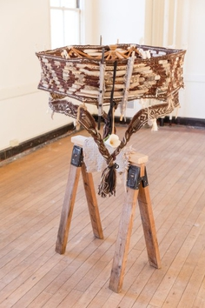 | Kira Dominguez Hultgren  The Woman He Saw in All the Women of Mexico, 2020  Warped revolutions in plant and animal fiber with printed imagery from exhibition catalog Luz Jiménez, símbolo de un pueblo milenario 1897-1965 (México, D.F.: Consejo Nacional para la Cultura y las Artes, Instituto Nacional de Bellas Artes, Museo Casa Estudio Diego Rivera y Frida Kahlo, Mexic-Arte Museum, 2000), loom bars left in place, installed on swift and sawhorse or other plinth; objetos personales de lana de fieltro y telar.  39" x 60" (variable) x 39,"  (DOMK-038) | $ 7,000
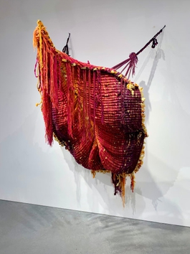 | Kira Dominguez Hultgren  To Carry Every Name but Your Own, 2022  Handspun ropes in sisal, silk, bullet-proof and stab-proof Kevlar; warped in wool, acrylic, cotton, linen, silk; loom bars; zip ties  (DOMK-052) | $ 9,500
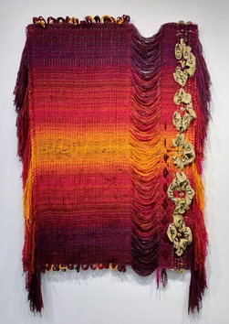 | Kira Dominguez Hultgren  Luz, 2022  Wool, acrylic, cotton, linen, silk, sisal; fabric woven with the names of Luz (Malinche, Fuente de los cántaros, Lavandera, India con frutas, Tejedora, La molendera, La maestra rural, Vendedora mexicana de flores, Madre)  73" x 45" x 3"  (DOMK-053) | $ 8,000

