Carissa Potter "Making Being Here Enough"

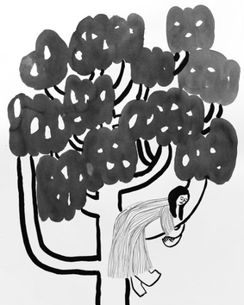 | Carissa Potter  Spring Plum Tree, 2020  verso  sumi ink on arches  30 x 24  (POTC-113) | $ 900.00
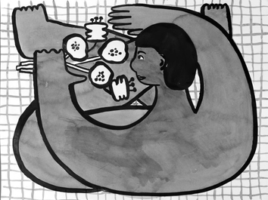 | Carissa Potter  Naked Lunch with Flowers, 2020  verso  sumi ink on arches  18 x 24  (POTC-121) | $ 750.00
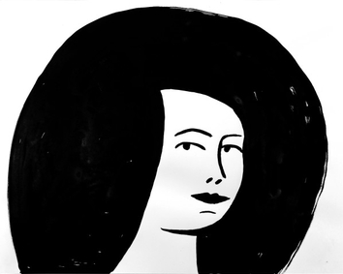 | Carissa Potter  Portrait with Black Hair, 2020  verso  sumi ink on arches  16 x 20  (POTC-137) | $ 550.00
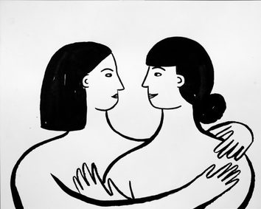 | Carissa Potter  When We Were Together, 2020  verso  sumi ink on arches  16 x 20  (POTC-150) | $ 550.00
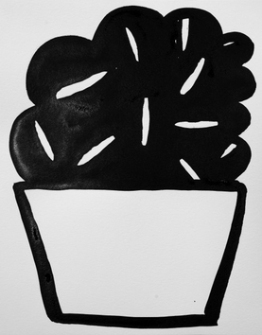 | Carissa Potter  Houseplant 5, 2020  verso  sumi ink on lettra  14 x 11  (POTC-124) | $ 250.00
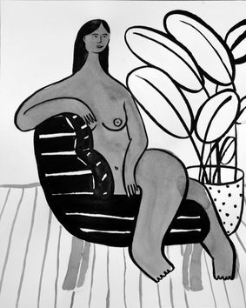 | Carissa Potter  Nude in Chair , 2020  verso  sumi ink on arches  20 x 16  (POTC-126) | $ 550.00
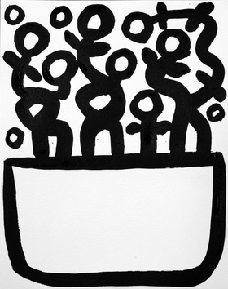 | Carissa Potter  Houseplant 3, 2020  verso  sumi ink on lettra  14 x 11  (POTC-123) | $ 250.00
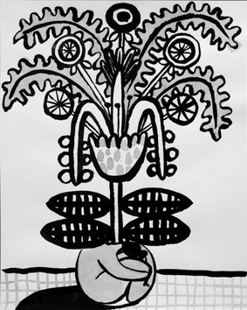 | Carissa Potter  Before you were born (2), 2020  verso  sumi ink on arches  20 x 16  (POTC-139) | $ 550.00
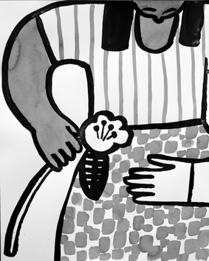 | Carissa Potter  Flower Gift 1, 2020  verso  sumi ink on arches  20 x 16  (POTC-142) | $ 550.00
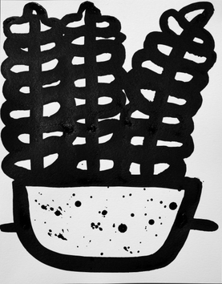 | Carissa Potter  Houseplant 2, 2020  verso  sumi ink on lettra  14 x 11  (POTC-134) | $ 250.00
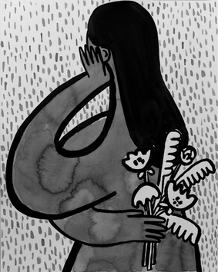 | Carissa Potter  Flowers Behind Back , 2020  verso  sumi ink on arches  20 x 16  (POTC-133) | $ 550.00
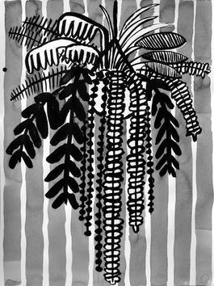 | Carissa Potter  Hanging Plant 3, 2020  verso  sumi ink on arches  24 x 18  (POTC-144) | $ 750.00
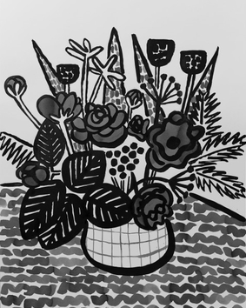 | Carissa Potter  Flowers From Michelle, 2020  verso  sumi ink on arches  30 x 24  (POTC-122) | $ 900.00
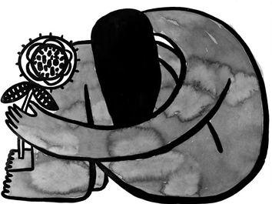 | Carissa Potter  Holding in There, 2020  verso  sumi ink on arches  18 x 24  (POTC-118) | $ 750.00
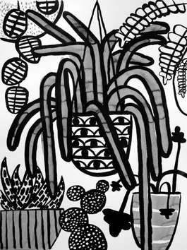 | Carissa Potter  Hanging Plants, 2020  verso  sumi ink on arches  24 x 18  (POTC-136) | $ 750.00
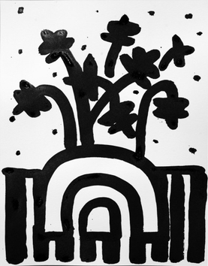 | Carissa Potter  Houseplant, 2020  verso  sumi ink on lettra  14 x 11  (POTC-151) | $ 250.00
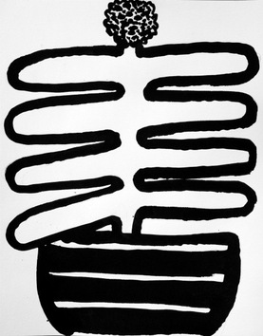 | Carissa Potter  Houseplant, 2020  verso  sumi ink on Lettra  14 x 11  (POTC-120) | $ 250.00
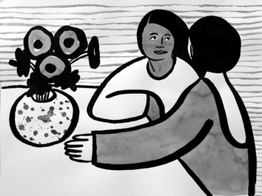 | Carissa Potter  Listening to Each Other , 2020  verso  sumi ink on arches  18 x 24  (POTC-146) | $ 750.00
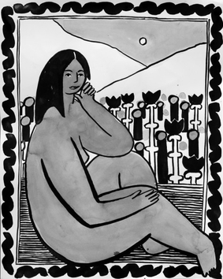 | Carissa Potter  Portrait with Field of Flowers, 2020  verso  sumi ink on arches  20 x 16  (POTC-127) | $ 550.00
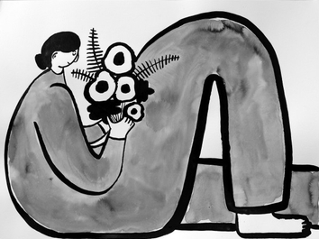 | Carissa Potter  Horizontal with Bent Knee, 2020  verso  sumi ink on arches  18 x 24  (POTC-145) | $ 750.00
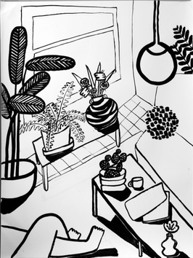 | Carissa Potter  Living Room  verso  sumi ink on arches  46.25 x 38.875  (POTC-152) | $ 1,000.00
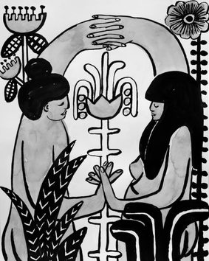 | Carissa Potter  We Came Together 2 , 2020  verso  sumi ink on arches  20 x 16  (POTC-148) | $ 550.00
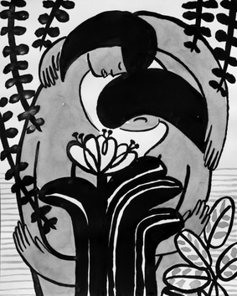 | Carissa Potter  We Came Together, 2020  verso  sumi ink on arches  20 x 16  (POTC-132) | $ 550.00
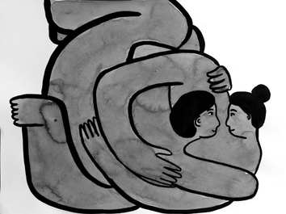 | Carissa Potter  Seeing You Seeing Me, 2020  verso  sumi ink on arches  18 x 24  (POTC-109) | $ 750.00
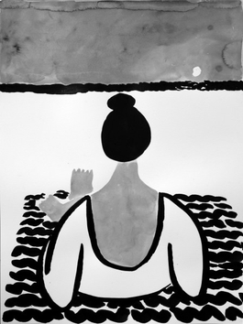 | Carissa Potter  Looking at the sun set, feeling time, 2020  verso  sumi ink on arches  24 x 18  (POTC-119) | $ 750.00
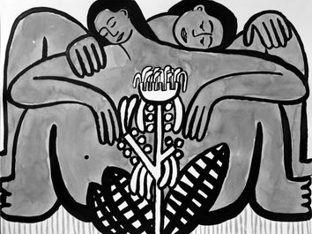 | Carissa Potter  Before You Were Born, 2020  verso  sumi ink on arches  18 x 24  (POTC-135) | $ 750.00
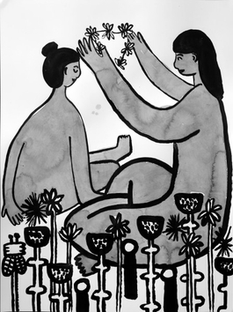 | Carissa Potter  How I Imagined it Would Be, 2020  verso  sumi ink on arches  24 x 18  (POTC-147) | $ 750.00
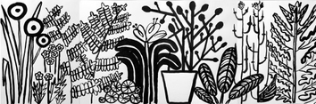 | Carissa Potter  Untitled, 2020  verso  sumi ink on arches  24 x 72  (POTC-111) | $ 2,000.00
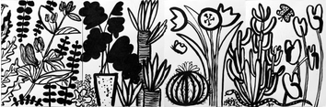 | Carissa Potter  Untitled , 2020  verso  sumi ink on arches  24 x 18  (POTC-110) | $ 750.00
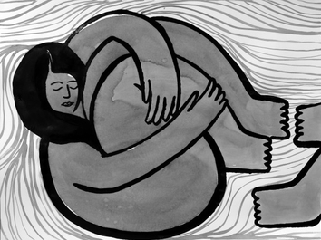 | Carissa Potter  Me with You, 2020  verso  sumi ink on arches  18 x 24  (POTC-128) | $ 750.00
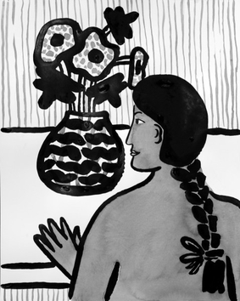 | Carissa Potter  Still Life with Person , 2020  verso  sumi ink on arches  20 x 16  (POTC-130) | $ 550.00
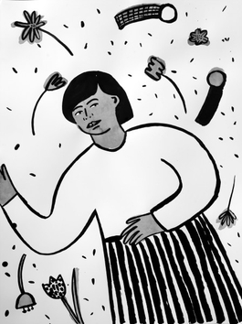 | Carissa Potter  Laying in a Field, 2020  verso  sumi ink on arches  24 x 18  (POTC-138) | $ 750.00
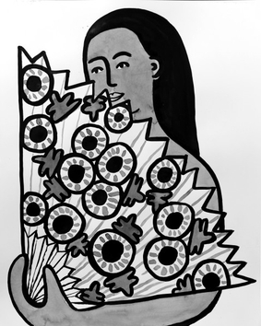 | Carissa Potter  Summer Breeze, 2020  verso  sumi ink on arches  20 x 16  (POTC-131) | $ 550.00
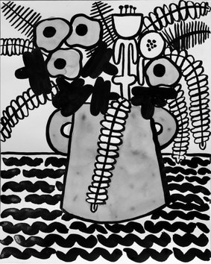 | Carissa Potter  Still Life , 2020  verso  sumi ink on arches  20 x 16  (POTC-129) | $ 550.00
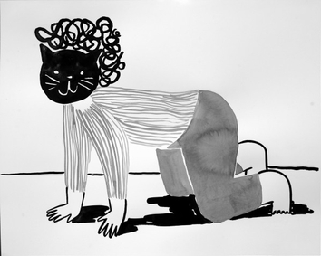 | Carissa Potter  Cat Mask, 2020  verso  sumi ink on arches  16 x 20  (POTC-141) | $ 550.00
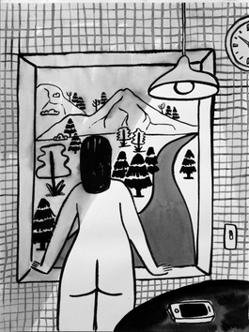 | Carissa Potter  Thinking about the Could Have Been, 2020  verso  sumi ink on arches  24 x 18  (POTC-143) | $ 750.00
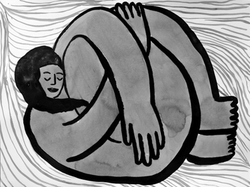 | Carissa Potter  Me Without You , 2020  verso  sumi ink on arches  18 x 24  (POTC-149) | $ 750.00

